main.py
│
│ "Run the application"
│
▼
main_agent.py
│
│ "Plan and orchestrate"
│
▼
┌─────────────────────────────────────┐
│ MAIN / SUPERVISOR AGENT │
└──────────────────┬──────────────────┘
│
DeepAgent delegation
│
┌───────────┼───────────┐
▼ ▼ ▼
Research Analysis Writer
Agent Agent Agent
│ │ │
└───────────┼───────────┘
▼
Shared Files

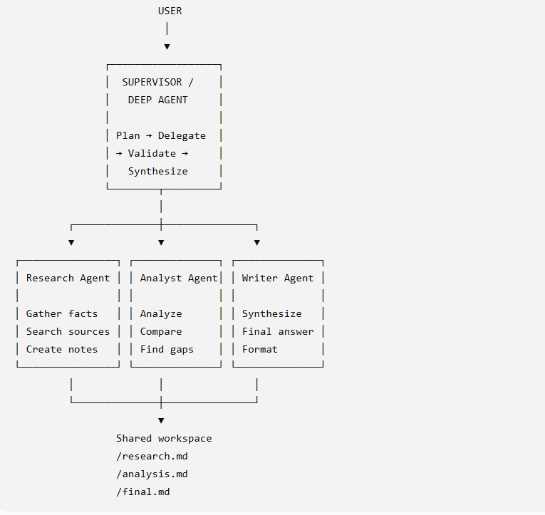

Multi-Agent DeepAgent System ---------------------------- Architecture: Supervisor Deep Agent | +-- Research Agent | +-- Analysis Agent | +-- Writer Agent Built with: - LangChain - Deep Agents - OpenAI – Tavily

python multi_agent.py
Enter your question: Compare Microsoft, Google and Amazon's strategies for enterprise generative AI and recommend which has the strongest competitive position.
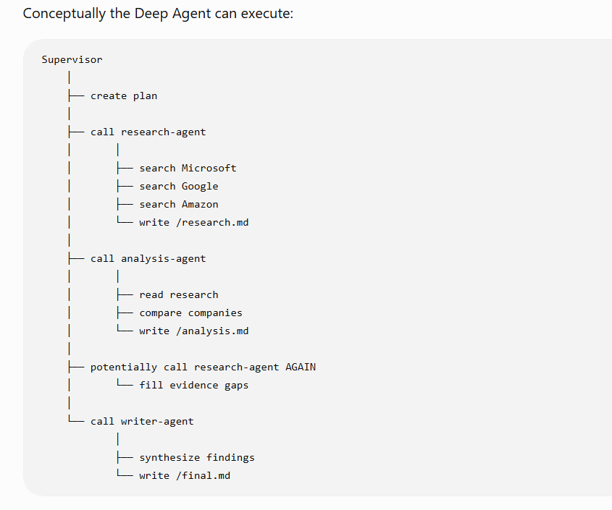

This is an important distinction from simply chaining three LLM calls. The Deep Agent acts as an orchestrator that decides when to delegate, while specialized sub-agents maintain more focused contexts. DataCamp describes this as “context quarantine”: specialized work stays out of the primary agent's context until its useful result is returned.
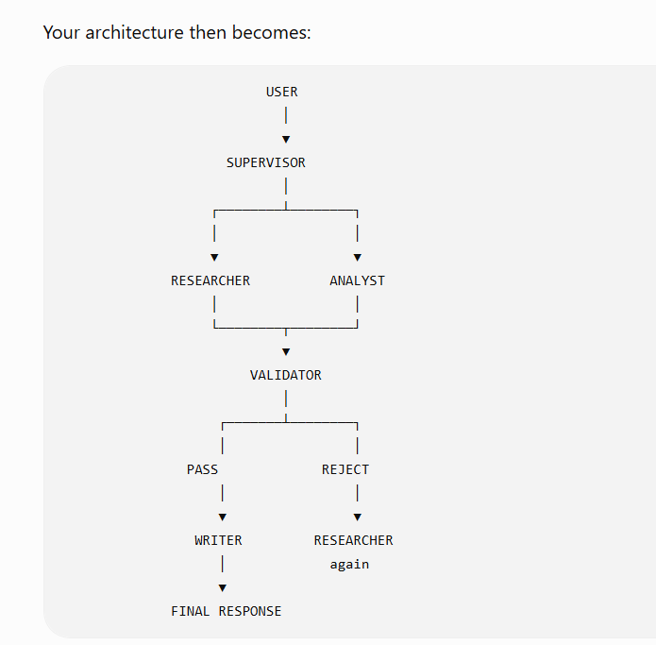
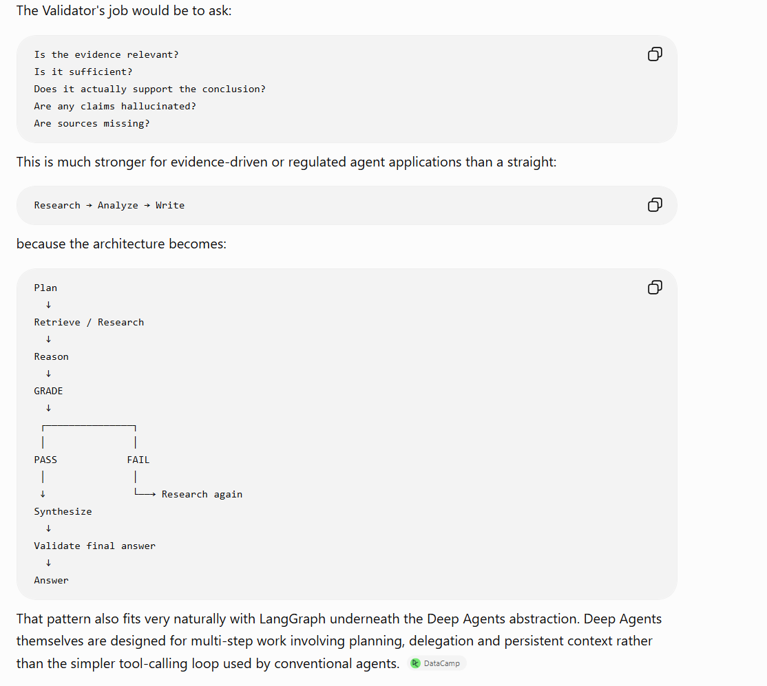

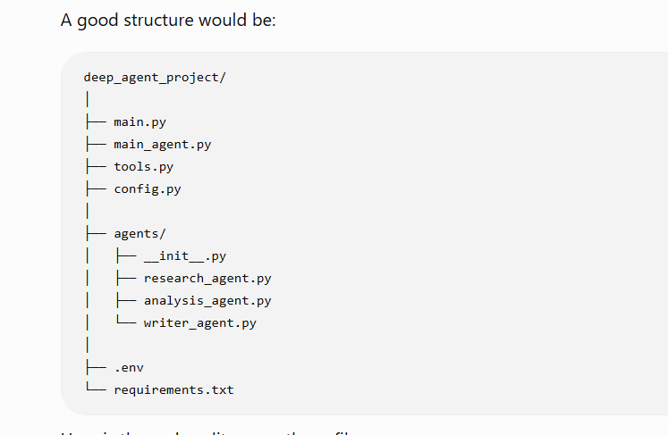

Key Capabilities & Visual Design
Autonomous Multi-Agent Neural Topology & Dynamic Visualizer:

Live interactive SVG/Canvas graph displaying the Supervisor Orchestrator Agent, Research Agent, Analysis Agent, Writer Agent, and the Shared Workspace Filesystem (/research.md, /analysis.md, /final.md).
Dynamic real-time pulse animations on active agents, data flow connectors, and sub-task status telemetry.
Executive Research Control Launchpad:

Query input with multi-depth rigor selector (⚡ Quick Brief, 🔬 Comprehensive, 🪐 Exhaustive Intelligence Dossier).
Domain focus filters (🌐 Authoritative Web, 📊 Financial & SEC Filings, 📰 Industry News, 🎓 Academic & STEM Preprints).
Curated 1-click strategic research briefs (e.g., Enterprise GenAI Hyperscaler Moat Benchmark, Solid-State Battery Commercialization, 2nm Semiconductor Supply Chain).
Publication-Grade Intelligence Artifacts & Graphics:

Interactive Strategic Radar Matrix (Chart.js): Multi-dimensional comparative scoring.
Evidence Rigor Distribution Donut Chart: Breakdowns by source authority tier.
Strategic SWOT & Horizon Grid: Formatted strengths, bottlenecks, opportunities, and regulatory headwinds.
Publication Report Viewer (final.md): Editorial serif typography (Newsreader), formatted tables, blockquotes, KaTeX math rendering, and copy/export utilities.
Deep Evidence Dossier (research.md) & Strategic Logic Matrix (analysis.md): Fact vs. Inference vs. Assumption matrices with verified URLs.
Live Telemetry, Streaming & Export Suite:

Real-time Server-Sent Events (SSE) telemetry showing thoughts, Tavily searches, and calculator calls.
One-click export to formatted Word (.docx), Markdown (.md), Print / PDF, and Read-Aloud Text-to-Speech (TTS).

Dossier archive drawer for historical research retrieval.

python app.py

Open http://localhost:8501 in your browser.

Troubleshooting
Root-cause conclusion
The application is not currently idle. The 30% value is stale telemetry, while the agent graph continues executing, timing out, retrying, and sometimes delegating additional work.
For active task 35d7b4b8-4fd, LangSmith shows:
- The graph started at 09:10:34 UTC.
- Research searches and model processing continued afterward.
- Analysis-agent started at 09:13:48.
- Its first model request ran for exactly 60 seconds and was cancelled.
- The two-second backoff occurred.
- Analysis-agent retried and completed in approximately six seconds.
- The orchestrator subsequently delegated more research.
- Another model call remained active while the local UI still showed 30%.
The local task record still contained only four logs, with active_agent="orchestrator" and duration_seconds=0.
Primary cause: ainvoke() is opaque to the UI
The application sets progress to 30 immediately before this call:
result = await agent.ainvoke(initial_state, config=trace_config)
It does not update progress again until the entire multi-agent graph returns, fails, or reaches validation.
Consequently, all of these operations happen invisibly:
- Model calls
- Subagent delegation
- Tavily searches
- File reads and writes
- Timeout attempts
- Retry backoffs
- Additional research requested by the orchestrator
- Analysis and writer execution
The SSE endpoint is working, but it repeatedly sends the same unchanged task dictionary every 0.6 seconds. last_progress is declared but unused.
Relevant locations:
- Static 30% checkpoint: [app.py](C:\\AgenticAI\\Week 3 - Session 1\\Mastering-Agentic-AI-Week3-Session1\\Scout AI\\app.py)
- Opaque graph invocation: [app.py](C:\\AgenticAI\\Week 3 - Session 1\\Mastering-Agentic-AI-Week3-Session1\\Scout AI\\app.py)
- Repeated SSE payload: [app.py](C:\\AgenticAI\\Week 3 - Session 1\\Mastering-Agentic-AI-Week3-Session1\\Scout AI\\app.py)
- Frontend only displays received progress: [index.html](C:\\AgenticAI\\Week 3 - Session 1\\Mastering-Agentic-AI-Week3-Session1\\Scout AI\\templates\\index.html)
Secondary cause: the 60-second timeout covers an entire subagent
The timeout middleware wraps the complete delegated task call:
await asyncio.wait_for(handler(request), timeout=60)
That means research-agent gets 60 seconds total for up to ten model turns, searches, file operations, and report generation. It is not 60 seconds per model call.
When a stage times out, Scout AI:
- Cancels the entire subagent.
- Waits two seconds.
- Restarts the whole subagent.
- Cancels it after another 60 seconds.
- Waits four seconds.
- Starts it a third time.
Maximum hidden time per delegation is therefore approximately:
60 + 2 + 60 + 4 + 60 = 186 seconds
Three sequential stages can consume at least 558 seconds—over nine minutes—before accounting for orchestrator calls, extra delegations, validation, or repair.
The active trace shows this exact behavior: analysis-agent’s first attempt was cancelled after 60 seconds and restarted.
See [agent_middleware.py](C:\\AgenticAI\\Week 3 - Session 1\\Mastering-Agentic-AI-Week3-Session1\\Scout AI\\agent_middleware.py).
Third cause: nested retry policies amplify delays
Model calls also use:
request_timeout=60
max_retries=2
Tavily has its own timeout and retries, and the entire subagent has two further retries. These overlapping policies can amplify work:
Provider retry × tool retry × whole-subagent retry
The outer subagent deadline can cancel an inner provider request before its own retry policy completes. Retrying the whole stage also repeats successful searches and file reads.
Fourth cause: dynamic orchestration causes rework
The orchestrator is an LLM-driven supervisor rather than a deterministic stage graph. The active trace shows it delegated analysis, retried analysis, and then issued another research delegation.
That behavior may be legitimate gap-filling, but it has no strict stage-transition state such as:
research complete → analysis complete → writer complete
Turn limits prevent infinite model loops, but they do not prevent:
- Repeating a completed stage
- Requesting extra research
- Re-reading artifacts
- Failing to recognize that a stage output is sufficient
- Spending most turns on tool navigation
max_concurrency=5 does not solve this. It limits simultaneous work; it does not limit sequential rework or publish progress.
Fifth cause: provider latency
The active LangSmith trace contains model calls lasting approximately:
- 24 seconds
- 55 seconds
- 60 seconds before cancellation
Nebius/Qwen latency is therefore a material contributor. Large /research.md and /analysis.md inputs can further increase prompt processing time.
The application currently cannot distinguish:
- A slow model response
- A timed-out attempt
- Retry backoff
- Active Tavily search
- A genuinely stalled graph
All appear as “30% — orchestrator.”
Recommended fixes
1. Stream graph events instead of awaiting one opaque result
Replace agent.ainvoke() with LangGraph event/state streaming:
agent.astream_events(...)
or:
agent.astream(..., stream_mode="updates", subgraphs=True)
Translate events into task telemetry:
Event | UI state
task starts with research-agent | 35%, Research Agent
Tavily search starts/completes | 40–50%, search count
/research.md written | 55%, Research complete
analysis-agent starts | 60%
/analysis.md written | 75%
writer-agent starts | 80%
/final.md written | 95%
Validation passes | 100%
Also emit:
- Current agent
- Current tool
- Turn number and limit
- Retry attempt
- Last activity time
- Elapsed backend duration
- File sizes
- Provider-call status
This is the immediate fix for the misleading 30%.
2. Replace the LLM supervisor with an explicit stage graph
The most reliable design is:
Research
↓
Validate /research.md
↓
Analysis
↓
Validate /analysis.md
↓
Writer
↓
Validate /final.md
↓
Complete
Allow at most one targeted repair transition per stage.
The orchestrator can still formulate task descriptions, but application code should own stage transitions. This prevents repeated or out-of-order delegation and provides natural progress milestones.
3. Redesign timeout boundaries
Recommended policy:
- Individual LLM request: 60 seconds
- Tavily request: 60 seconds
- Research stage: 240–300 seconds overall
- Analysis stage: 120–180 seconds overall
- Writer stage: 120–180 seconds overall
- Complete workflow watchdog: 8–12 minutes
Do not impose a 60-second deadline on an entire ten-turn research agent.
4. Use one retry layer
Choose one owner for retries:
- Provider/tool calls retry transient network failures.
- Stage execution does not restart wholesale unless it is checkpointed.
- Maximum one stage-level recovery attempt.
If whole-stage retry remains, disable or reduce lower-level retries to prevent multiplication.
5. Resume from checkpoints instead of restarting agents
Use a LangGraph checkpointer and persist:
- Completed searches
- Current turn
- Files written
- Stage state
- Retry count
A timeout should resume the incomplete operation rather than rerun the complete agent from its original task.
6. Add a progress callback/middleware
Add middleware to each specialist that emits events when:
- Model turn begins/ends
- Tool begins/ends
- A timeout occurs
- Backoff begins
- A retry begins
- A shared file is written
Pass those events through an asyncio.Queue consumed by the task logger and SSE endpoint.
7. Make progress honest
Avoid a continuously increasing fake percentage. Use milestone progress plus an activity indicator:
60% — Analysis Agent
Model call 1/7
Attempt 2/3
Last activity: 8 seconds ago
If there is no event for 45 seconds:
Provider response is slow; timeout in 15 seconds
During backoff:
Analysis attempt timed out. Retrying in 2 seconds.
8. Add a workflow watchdog and cancellation
A workflow should never remain in_progress indefinitely.
Add:
- Overall deadline
- last_activity_at
- Stalled-state detection
- User cancellation endpoint
- Terminal timed_out status
- Cleanup of child coroutines and HTTP requests
9. Reduce provider latency and context size
- Cap research and analysis artifact size.
- Store structured evidence rather than verbose prose between stages.
- Pass only relevant excerpts to analysis and writer.
- Track prompt tokens in telemetry.
- Consider a faster model for routing/tool selection and reserve the larger model for final synthesis.
- Avoid reading 1,000 lines when a structured 100-line summary would suffice.
Recommended implementation order
- Add LangGraph event streaming and live SSE telemetry.
- Change timeout scope from whole-subagent 60 seconds to stage-specific deadlines.
- Remove overlapping retry layers.
- Convert orchestration into explicit stage transitions.
- Add checkpointed recovery and a workflow watchdog.
- Optimize provider/model latency and artifact size.
The essential point is that 30% is currently not a measurement of execution progress. It is the last application-authored log before control enters the DeepAgents graph. LangSmith confirms the graph remains active underneath, but its activity is not connected to the UI.

The GRAPH_RECURSION_LIMIT is 50 in config.py, but application failed with "Live research failed: Recursion limit of 25 reached without hitting a stop condition. You can increase the limit by setting the `recursion_limit` config key.
For troubleshooting, visit: **https://docs.langchain.com/oss/python/langgraph/errors/GRAPH\_RECURSION\_LIMIT** ", why?
The “25” proves the failure is occurring in a graph invocation that did not receive Scout AI’s top-level recursion_limit=50. I’ll trace how DeepAgents launches delegated subgraphs and compare that path with the configuration passed to the outer orchestrator, so we can identify exactly which invocation is falling back to LangGraph’s default.

Research the most recommended cars with high reliability , fuel efficiency, resale value and low total cost of ownership.

